1. copy the board I created before

Board address:<https://trello.com/b/IbXFiNmr/bug-tracker>

1. Click button of ‘...’

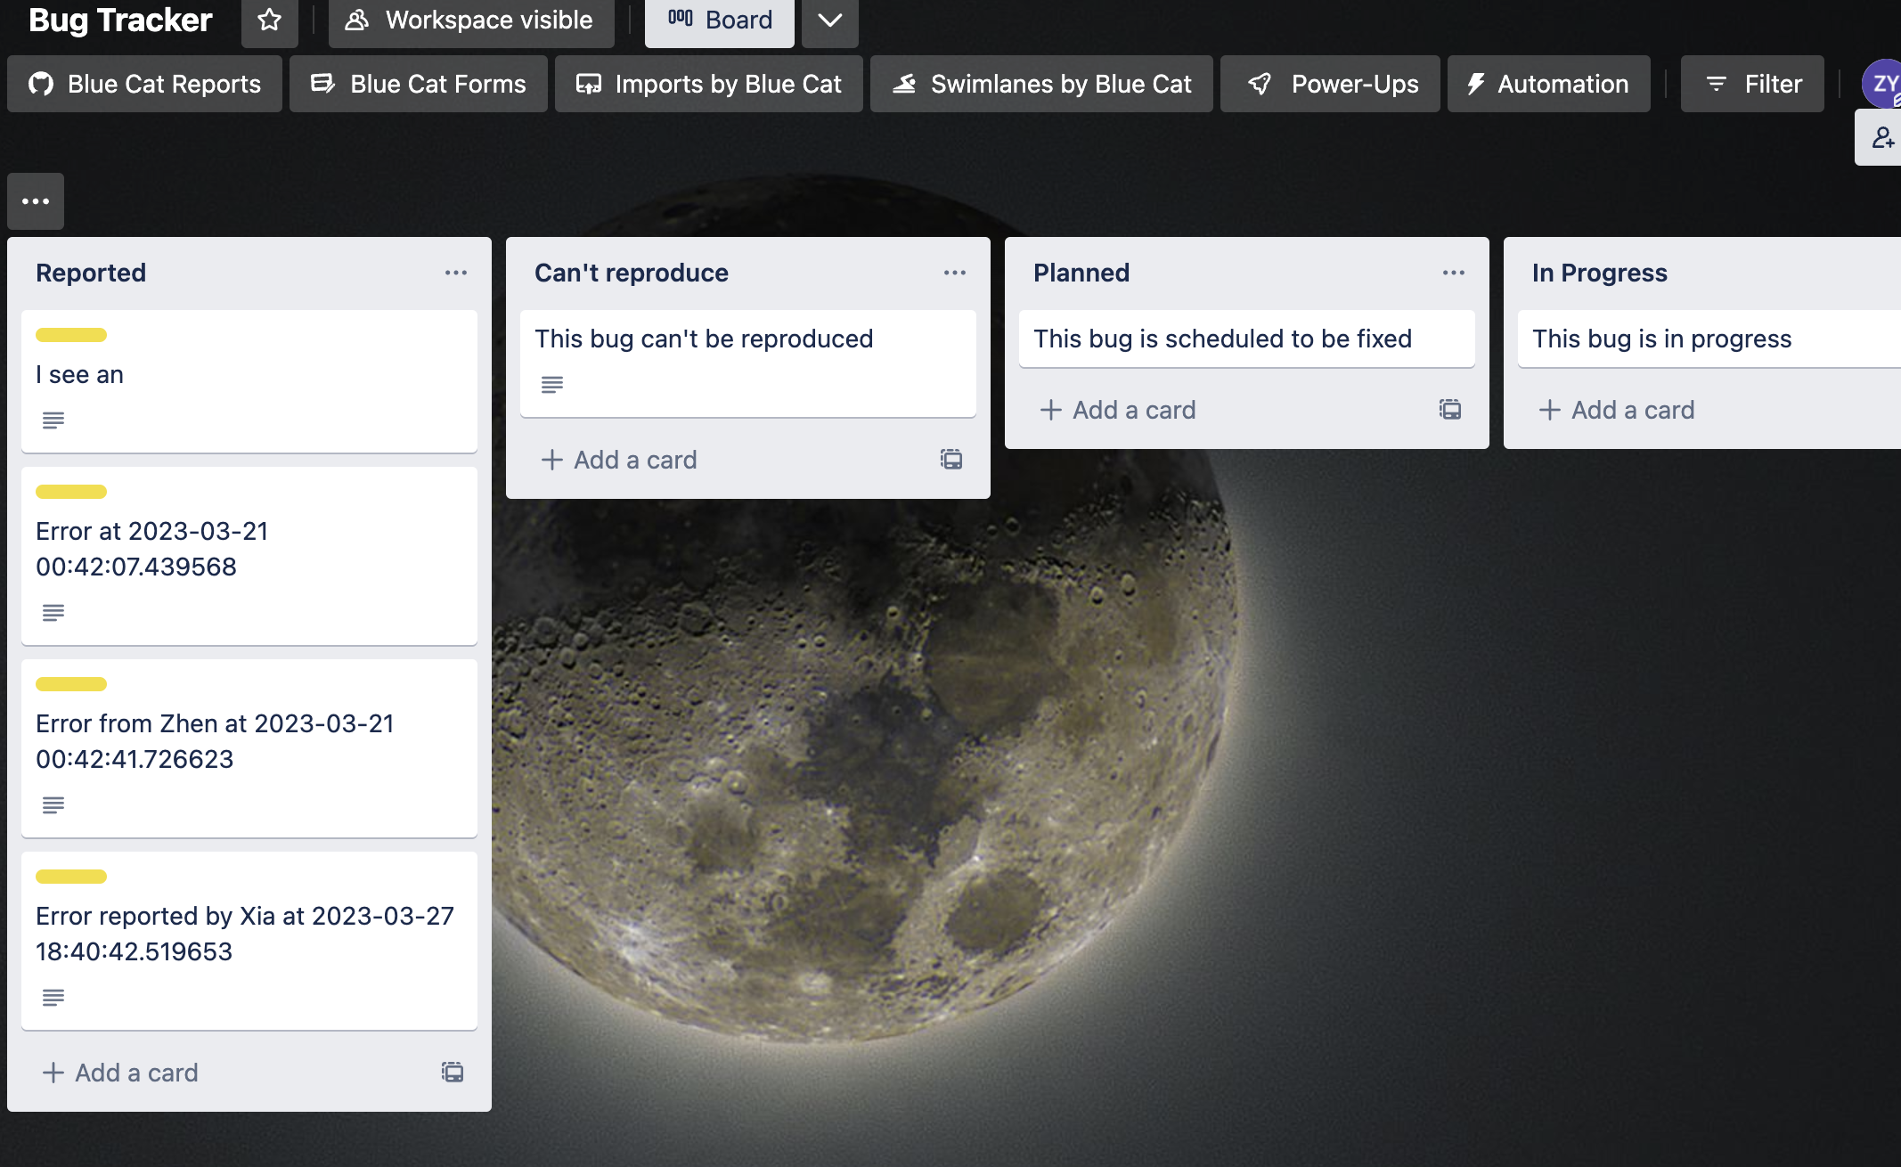

3. click more in the right menu

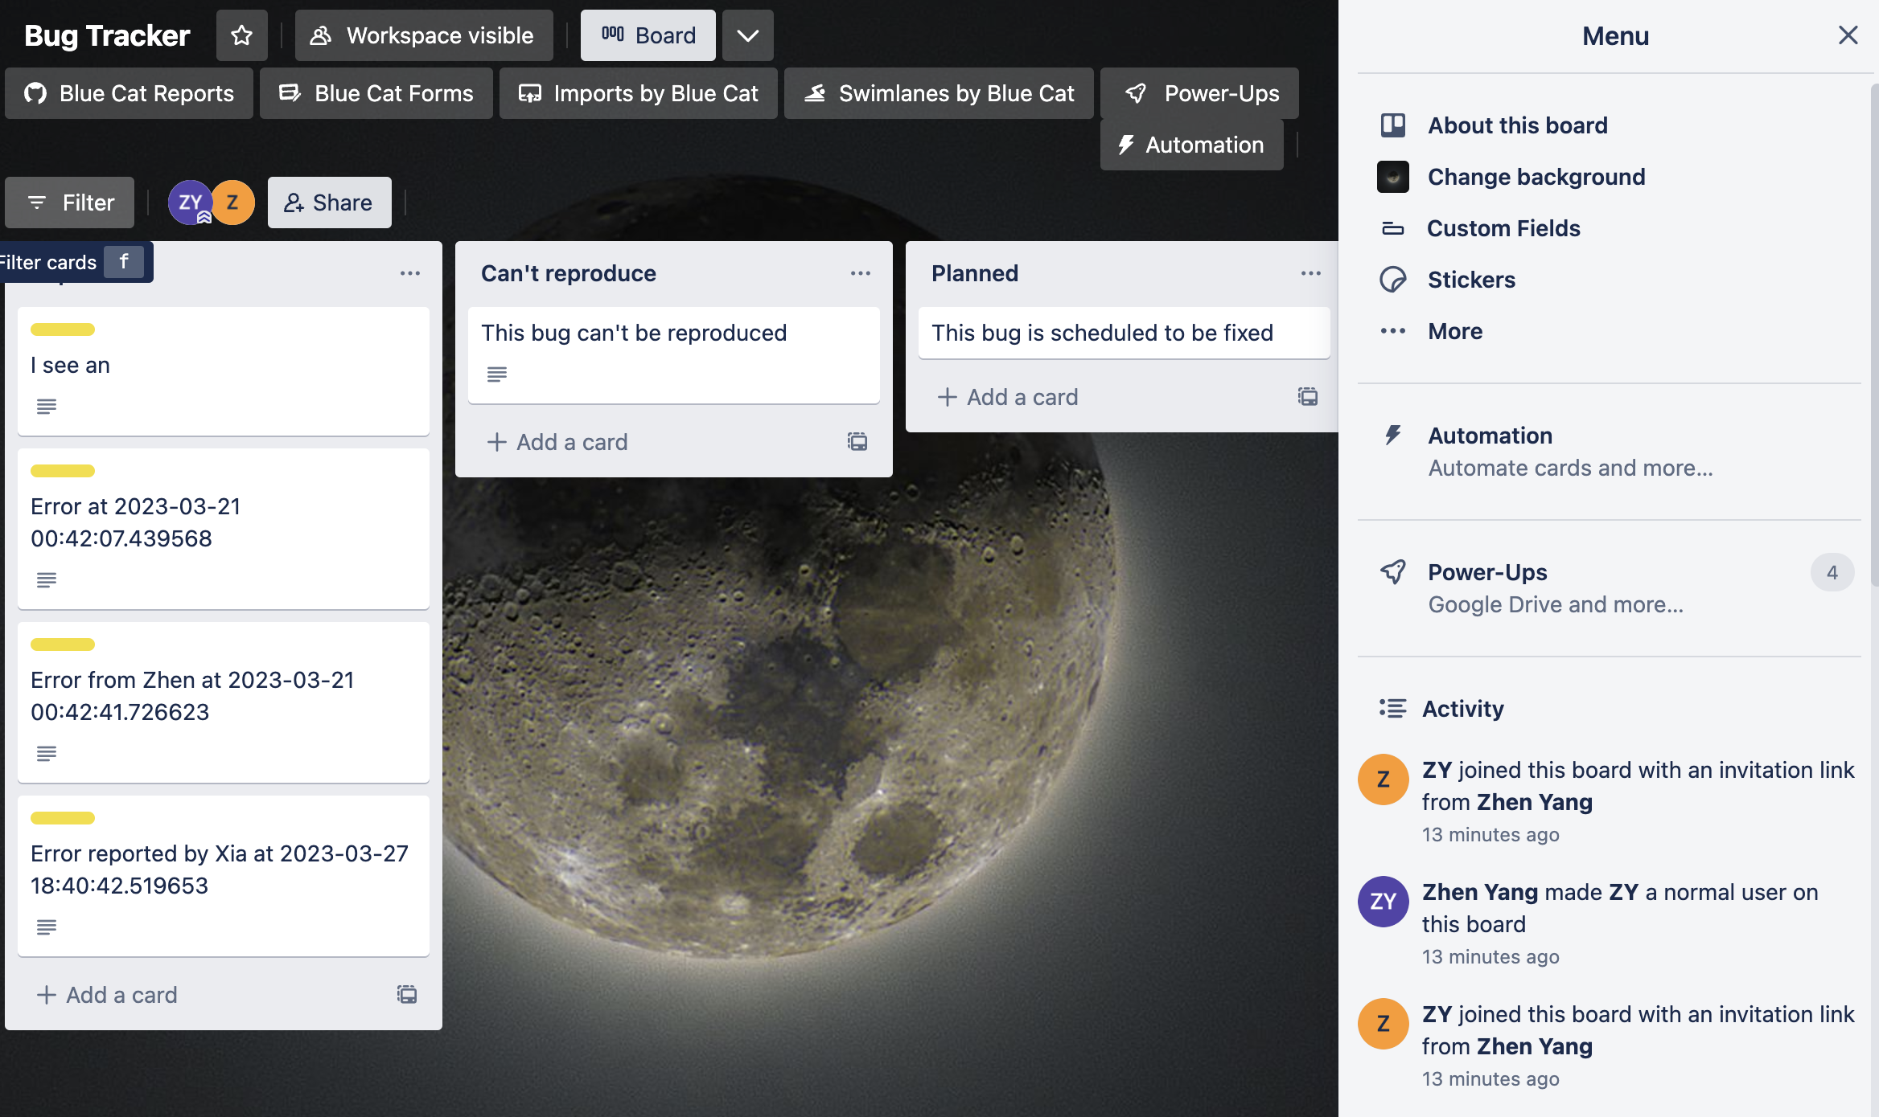

1. click copy board

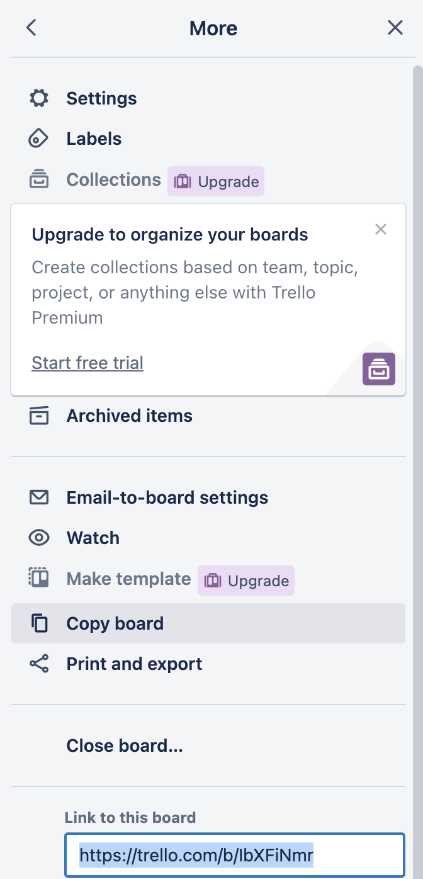

1. to link the board to our application

A. Get your API key:

Visit the Trello API key page: https://trello.com/app-key

Log in with your Trello account, if you haven't already.

You will see your API key displayed on the page. Make a note of it, as you'll need it later.

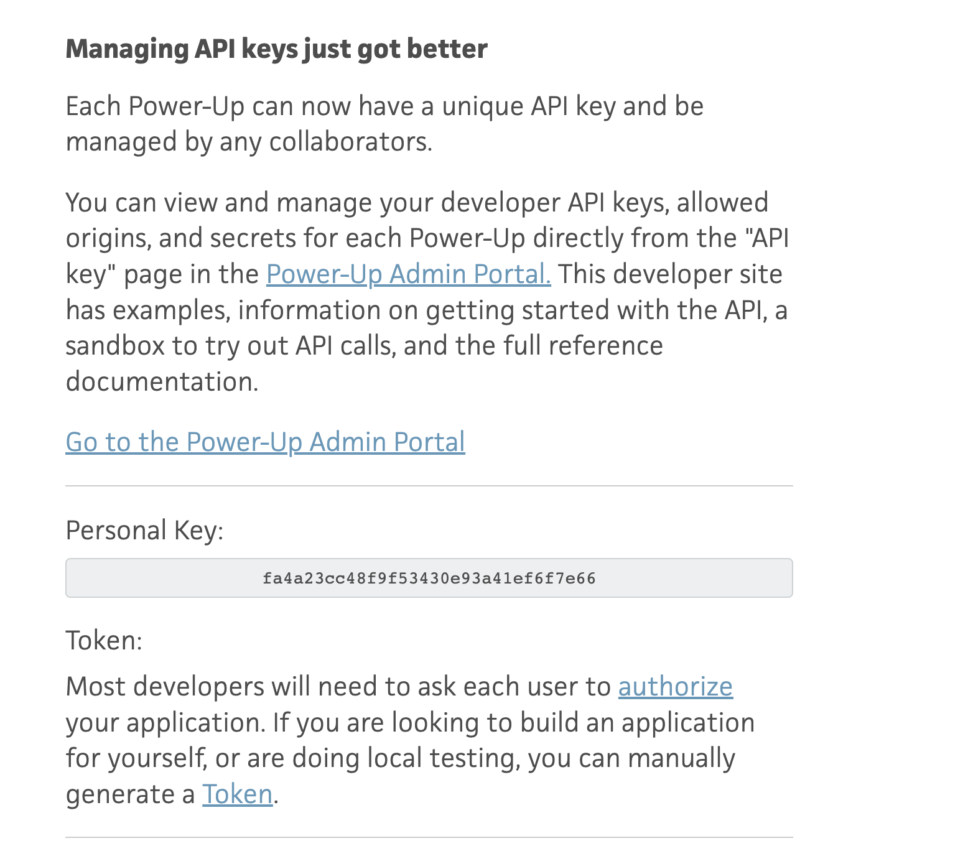

B. Generate your Trello token:

On the same API key page (https://trello.com/app-key), locate the "Token" section.

Click the "Token" link

1. paste the key and token to the application.py

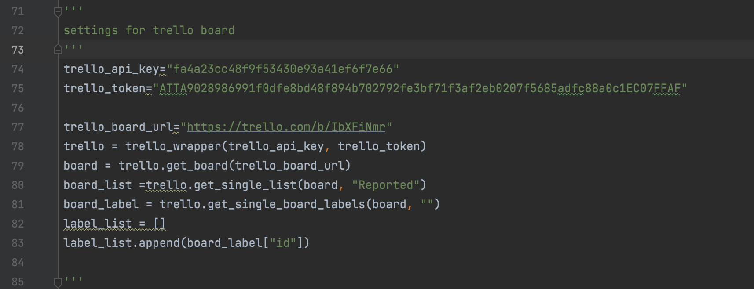

Replace the key, token and url variables with those of new board.